Lab Exercise on JavaFX

# Question 1

Write a program that displays the following stage using more than one pane

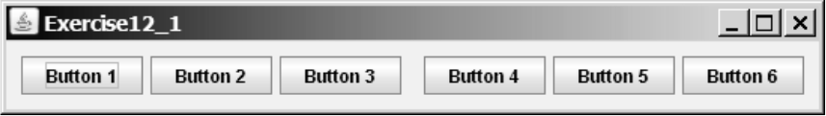

**CODE:**

import javafx.application.Application;

import javafx.scene.Scene;

import javafx.scene.control.Button;

import javafx.scene.layout.HBox;

import javafx.stage.Stage;

public class q1 extends Application {

@Override

public void start(Stage primaryStage) throws Exception {

primaryStage.setTitle("Exercise12_1");

Button btn1 = new Button("Button 1");

Button btn2 = new Button("Button 2");

Button btn3 = new Button("Button 3");

Button btn4 = new Button("Button 4");

Button btn5 = new Button("Button 5");

Button btn6 = new Button("Button 6");

HBox hbox = new HBox(btn1, btn2, btn3, btn4, btn5, btn6);

hbox.setSpacing(10);

Scene scene = new Scene(hbox, 400, 100);

primaryStage.setScene(scene);

primaryStage.show();

}

public static void main(String[] args) {

Application.launch(args);

}

}

**OUTPUT:**



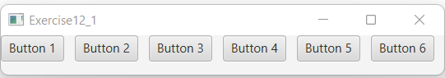

# Question 2

Write a program that displays four lines of text in four Labels:

* Write your name, ID, Address, Phone in labels respectively.
* Set the background of the labels to white.
* Set the text color of the labels to black, blue, cyan, green respectively.
* Set the font of each label to TimesRoman, bold, and 20 pixels.
* Set the border of each label to a line border with yellow colour.

**CODE:**

import javafx.application.Application;

import javafx.scene.Scene;

import javafx.stage.Stage;

import javafx.scene.control.Button;

import javafx.scene.control.Label;

import javafx.scene.control.TextField;

import javafx.scene.layout.GridPane;

import javafx.geometry.Insets;

import javafx.geometry.Pos;

public class q2 extends Application {

public static void main(String[] args) {

launch(args);

}

@Override

public void start(Stage primaryStage) throws Exception {

Label name=new Label("Name");

name.setStyle("-fx-font:bold 20px TimesRoman;");

Label myName=new Label("Gokul Jayan");

myName.setStyle("-fx-font:bold 20px TimesRoman;" + "-fx-font-weight:bold;" + "-fx-border-color: yellow;" + "-fx-background-color : white;" + "-fx-padding : 5;" + "-fx-text-fill :black;" );

Label id = new Label("ID");

id.setStyle("-fx-font:bold 20px TimesRoman;");

Label myId = new Label("20BCE1249");

myId.setStyle("-fx-font:bold 20px TimesRoman;" + "-fx-font-weight:bold;" + "-fx-border-color: yellow;" + "-fx-background-color : white;" + "-fx-padding : 5;" + "-fx-text-fill :blue;" );

Label address = new Label("Address");

address.setStyle("-fx-font:bold 20px TimesRoman;");

Label myAddress = new Label("Chaithanya, Kattachira, Pallickal(P.O)");

myAddress.setStyle("-fx-font:bold 20px TimesRoman;" + "-fx-font-weight:bold;" + "-fx-border-color: yellow;" + "-fx-background-color : white;" + "-fx-padding : 5;" + "-fx-text-fill :cyan;" );

Label phone = new Label("Phone");

phone.setStyle("-fx-font:bold 20px TimesRoman;");

Label myPhone = new Label("8156932713");

myPhone.setStyle("-fx-font:bold 20px TimesRoman;" + "-fx-font-weight:bold;" + "-fx-border-color: yellow;" + "-fx-background-color : white;" + "-fx-padding : 5;" + "-fx-text-fill :green;" );

GridPane root = new GridPane();

root.setPadding(new Insets(10, 10, 10, 10));

root.setVgap(5);

root.setHgap(10);

root.addRow(0, name, myName);

root.addRow(1, id, myId);

root.addRow(2, address,myAddress);

root.addRow(3, phone,myPhone);

Scene scene=new Scene(root,800,200);

primaryStage.setScene(scene);

primaryStage.setTitle("Personal Details");

primaryStage.show();

}

}

**OUTPUT:**



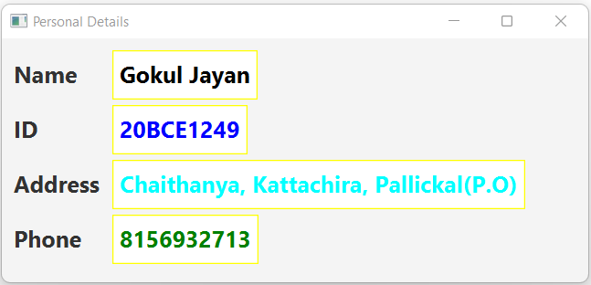

# Question 3

Display a stage that contains nine labels. A label may display an image icon for X, an image icon for O, or nothing. What to display is randomly decided. Use the Math.random() method to generate an integer 0, 1, or 2, which corresponds to displaying a cross image icon, a not image icon, or nothing.

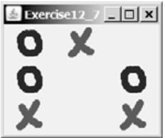

**CODE:**

import javafx.application.Application;

import javafx.geometry.Pos;

import javafx.scene.Scene;

import javafx.scene.image.Image;

import javafx.scene.image.ImageView;

import javafx.scene.layout.GridPane;

import javafx.stage.Stage;

public class q3 extends Application {

@Override

public void start(Stage primaryStage) {

GridPane pane = new GridPane();

for (int i = 0; i < 3; i++)

{

for (int j = 0; j < 3; j++)

{

int random = (int)(Math.random() * 3);

if (random == 0 || random ==1)

{

String image = (random == 0) ? "x.png" : "o.png";

ImageView imageView = new ImageView(image);

imageView.setFitHeight(100);

imageView.setFitWidth(100);

pane.add(imageView, j, i);

}

}

}

Scene scene = new Scene(pane, 150, 150);

primaryStage.setTitle("XOX");

primaryStage.setScene(scene);

primaryStage.show();

}

public static void main(String[] args) {

Application.launch(args);

}

}

**OUTPUT:**

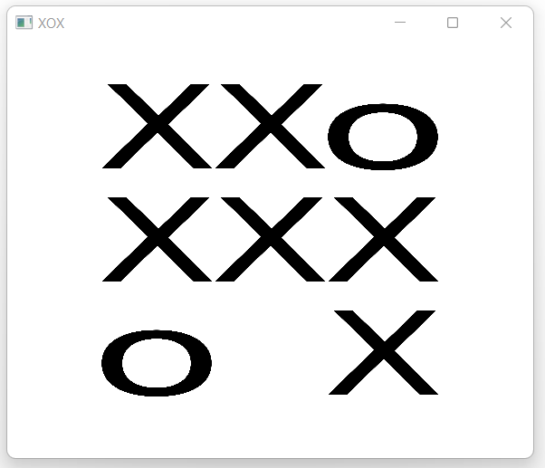

# Question 4

Using any database of your choi

ce, create a table VITStudent with the following fields: RegNo, FirstName, LastName, Gender, Program (BCE, BEE, BME, BAI, BCL), NoOfCreditsEarned, Joining Year.

**CODE (for 1,3 & 4):**

import javafx.application.Application;

import javafx.collections.FXCollections;

import javafx.collections.ObservableList;

import javafx.geometry.Insets;

import javafx.geometry.Pos;

import javafx.scene.Scene;

import javafx.scene.control.Button;

import javafx.scene.control.CheckBox;

import javafx.scene.control.ChoiceBox;

import javafx.scene.control.DatePicker;

import javafx.scene.control.ListView;

import javafx.scene.control.RadioButton;

import javafx.scene.layout.GridPane;

import javafx.scene.text.Text;

import javafx.scene.control.TextField;

import javafx.scene.control.ToggleGroup;

import javafx.scene.control.ToggleButton;

import javafx.stage.Stage;

import java.sql.*;

public class q4 extends Application {

@Override

public void start(Stage stage) throws Exception

{

GridPane gridPane = new GridPane();

Text l1 = new Text("Reg No");

TextField textField1 = new TextField();

gridPane.add(l1, 0, 0);

gridPane.add(textField1, 1, 0);

Text l2 = new Text("First Name");

TextField textField2 = new TextField();

gridPane.add(l2, 0, 1);

gridPane.add(textField2, 1, 1);

Text l3 = new Text("Last Name");

TextField textField3 = new TextField();

gridPane.add(l3, 0, 2);

gridPane.add(textField3, 1, 2);

Text l4 = new Text("Gender");

ToggleGroup groupGender = new ToggleGroup();

RadioButton maleRadio = new RadioButton("Male");

maleRadio.setToggleGroup(groupGender);

RadioButton femaleRadio = new RadioButton("Female");

femaleRadio.setToggleGroup(groupGender);

RadioButton othersRadio = new RadioButton("Others");

othersRadio.setToggleGroup(groupGender);

gridPane.add(l4, 0, 3);

gridPane.add(maleRadio, 1, 3);

gridPane.add(femaleRadio, 2, 3);

gridPane.add(othersRadio, 3, 3);

Text l5 = new Text("Program");

ChoiceBox programChoiceBox = new ChoiceBox();

programChoiceBox.getItems().addAll("BCE", "BEE", "BME", "BAI", "BCL");

gridPane.add(l5, 0, 4);

gridPane.add(programChoiceBox, 1, 4);

Text l6 = new Text("Credits");

TextField textField4 = new TextField();

gridPane.add(l6, 0, 5);

gridPane.add(textField4, 1, 5);

Button button1 = new Button("Submit");

Button button2 = new Button("Clear");

Button button3 = new Button("Search");

Button button4 = new Button("Update");

Button button5 = new Button("Delete");

gridPane.add(button1, 0, 6);

gridPane.add(button2, 1, 6);

gridPane.add(button3, 2, 6);

gridPane.add(button4, 4, 6);

gridPane.add(button5, 3, 6);

button4.setVisible(false);

gridPane.setMinSize(500, 500);

gridPane.setPadding(new Insets(10, 10, 10, 10));

gridPane.setVgap(5);

gridPane.setHgap(5);

gridPane.setAlignment(Pos.CENTER);

Scene scene = new Scene(gridPane, 400, 200);

stage.setTitle("VIT Student");

stage.setScene(scene);

stage.show();

button1.setOnAction((event) -> {

String regno = textField1.getText(); //setText()

String fname = textField2.getText();

String lname = textField3.getText();

String gender ="";

if(maleRadio.isSelected())

gender="Male";

else if(femaleRadio.isSelected())

gender="Male";

else

gender="Others";

String program = programChoiceBox.getValue().toString();

String credits = textField4.getText();

try

{

System.out.println("connecting to DB......");

Connection con=DriverManager.getConnection("jdbc:mysql://localhost:3306/javadb","root","sql@1234");

PreparedStatement ps = con.prepareStatement("insert into VITStudent values (?,?,?,?,?,?)");

ps.setString(1, regno);

ps.setString(2,fname);

ps.setString(3,lname);

ps.setString(4,gender);

ps.setString(5,program);

ps.setString(6,credits);

int count = ps.executeUpdate();

System.out.println(count + " no: of records inserted");

con.close();

}catch(Exception e){ System.out.println(e);}

});

button2.setOnAction((event) -> {

textField1.setText("");

textField2.setText("");

textField3.setText("");

maleRadio.setSelected(false);

femaleRadio.setSelected(false);

othersRadio.setSelected(false);

programChoiceBox.setValue("");

textField4.setText("");

});

button3.setOnAction((event) ->{

String regno;

String fname;

String lname;

String gender;

String program;

int credits;

regno=textField1.getText();

try

{

System.out.println("connecting to DB......");

Connection con=DriverManager.getConnection("jdbc:mysql://localhost:3306/javadb","root","sql@1234");

String sql = "select * from VITStudent where regno='"+regno+"';";

PreparedStatement ps = con.prepareStatement(sql);

ResultSet rs = ps.executeQuery();

if(rs.next()){

regno = rs.getString("regno");

fname = rs.getString("firstname");

lname = rs.getString("lastname");

gender = rs.getString("gender");

program = rs.getString("program");

credits = rs.getInt("credits");

//PreparedStatement ps = con.prepareStatement("insert into VITStudent values (?,?,?,?,?,?)");

textField1.setText(regno);

textField2.setText(fname);

textField3.setText(lname);

if(gender.equals("Male"))

maleRadio.setSelected(true);

else if(gender.equals("Female"))

femaleRadio.setSelected(true);

else

othersRadio.setSelected(true);

programChoiceBox.setValue(program);

textField4.setText(String.valueOf(credits));

button4.setVisible(true);

}

con.close();

}catch(Exception e){ System.out.println(e);}

});

button4.setOnAction((event) ->{

String regno=textField1.getText();

String credits = textField4.getText();

try

{

System.out.println("connecting to DB......");

Connection con=DriverManager.getConnection("jdbc:mysql://localhost:3306/javadb","root","sql@1234");

String sql = "update VITStudent set credits="+credits+" where regno='"+regno+"';";

PreparedStatement ps = con.prepareStatement(sql);

int count = ps.executeUpdate();

System.out.println(count + " no: of records updated");

button4.setVisible(false);

con.close();

}catch(Exception e){ System.out.println(e);}

});

button5.setOnAction((event)->{

String regno=textField1.getText();

try

{

System.out.println("connecting to DB......");

Connection con=DriverManager.getConnection("jdbc:mysql://localhost:3306/javadb","root","sql@1234");

String sql = "delete from VITStudent where regno='"+regno+"';";

PreparedStatement ps = con.prepareStatement(sql);

int count = ps.executeUpdate();

System.out.println(count + " no: of records deleted");

con.close();

}catch(Exception e){ System.out.println(e);}

});

}

public static void main(String args[]){

launch(args);

}

}

1. **Design a JavaFX program to read the above details from the user and save them into the table. Use appropriate UI controls.**

**OUTPUT:**

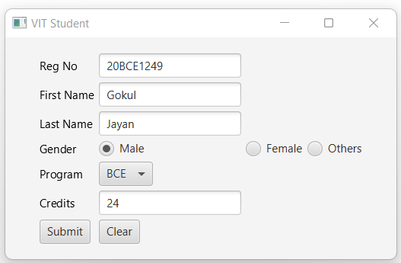

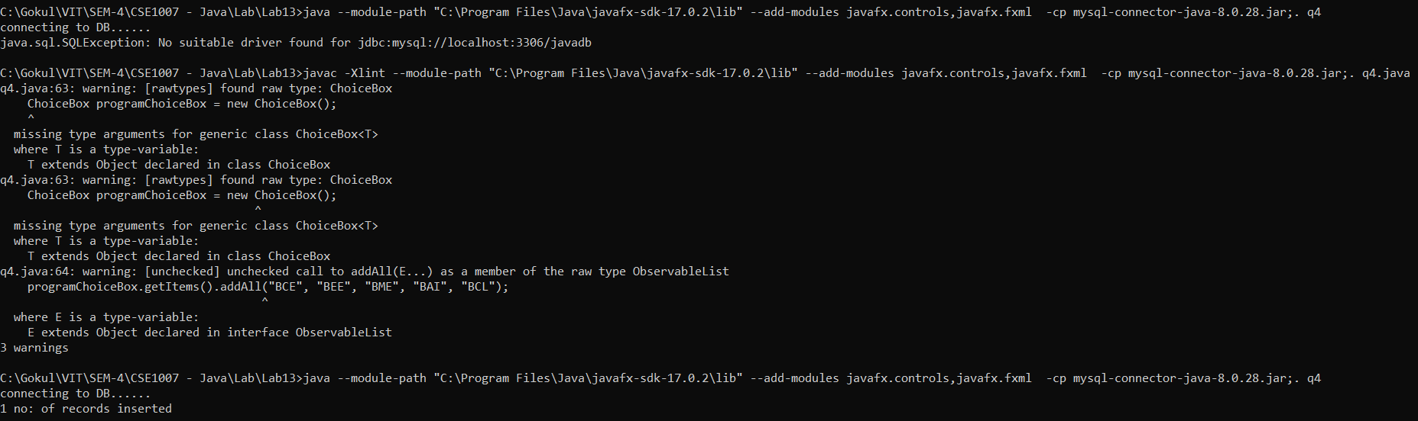

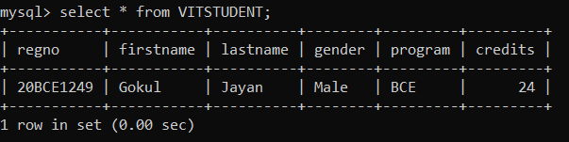

1. **Develop a JavaFX program that has three buttons “Next Record”, “Previous Record” and** **“Clear.” Use a text field to display the student’s details when the user clicks next or previous buttons. Clear the text field when the user clicks ‘clear’ button.**

**CODE:**

import javafx.application.Application;

import javafx.collections.FXCollections;

import javafx.collections.ObservableList;

import javafx.geometry.Insets;

import javafx.geometry.Pos;

import javafx.scene.Scene;

import javafx.scene.control.Button;

import javafx.scene.control.CheckBox;

import javafx.scene.control.ChoiceBox;

import javafx.scene.control.DatePicker;

import javafx.scene.control.ListView;

import javafx.scene.control.RadioButton;

import javafx.scene.layout.GridPane;

import javafx.scene.text.Text;

import javafx.scene.control.TextField;

import javafx.scene.control.ToggleGroup;

import javafx.scene.control.ToggleButton;

import javafx.stage.Stage;

import java.sql.*;

class Student{

String regno;

String fname;

String lname;

String gender;

String program;

int credits;

}

public class q5 extends Application {

@Override

public void start(Stage stage) throws Exception

{

GridPane gridPane = new GridPane();

Text l1 = new Text("Reg No");

TextField textField1 = new TextField();

gridPane.add(l1, 0, 0);

gridPane.add(textField1, 1, 0);

Text l2 = new Text("First Name");

TextField textField2 = new TextField();

gridPane.add(l2, 0, 1);

gridPane.add(textField2, 1, 1);

Text l3 = new Text("Last Name");

TextField textField3 = new TextField();

gridPane.add(l3, 0, 2);

gridPane.add(textField3, 1, 2);

Text l4 = new Text("Gender");

ToggleGroup groupGender = new ToggleGroup();

RadioButton maleRadio = new RadioButton("Male");

maleRadio.setToggleGroup(groupGender);

RadioButton femaleRadio = new RadioButton("Female");

femaleRadio.setToggleGroup(groupGender);

RadioButton othersRadio = new RadioButton("Others");

othersRadio.setToggleGroup(groupGender);

gridPane.add(l4, 0, 3);

gridPane.add(maleRadio, 1, 3);

gridPane.add(femaleRadio, 2, 3);

gridPane.add(othersRadio, 3, 3);

Text l5 = new Text("Program");

ChoiceBox programChoiceBox = new ChoiceBox();

programChoiceBox.getItems().addAll("BCE", "BEE", "BME", "BAI", "BCL");

gridPane.add(l5, 0, 4);

gridPane.add(programChoiceBox, 1, 4);

Text l6 = new Text("Credits");

TextField textField4 = new TextField();

gridPane.add(l6, 0, 5);

gridPane.add(textField4, 1, 5);

Button button1 = new Button("<-Prev");

Button button2 = new Button("Clear");

Button button3 = new Button("Next->");

gridPane.add(button1, 0, 6);

gridPane.add(button2, 2, 6);

gridPane.add(button3, 1, 6);

gridPane.setMinSize(500, 500);

gridPane.setPadding(new Insets(10, 10, 10, 10));

gridPane.setVgap(5);

gridPane.setHgap(5);

gridPane.setAlignment(Pos.CENTER);

Scene scene = new Scene(gridPane, 400, 200);

stage.setTitle("VIT Student");

stage.setScene(scene);

stage.show();

try

{

Student[] s =new Student[10];

int count=0, i=0;

System.out.println("connecting to DB......");

Connection con=DriverManager.getConnection("jdbc:mysql://localhost:3306/javadb","root","sql@1234");

String sql = "select * from VITStudent;";

PreparedStatement ps = con.prepareStatement(sql);

ResultSet rs = ps.executeQuery();

while(rs.next()){

s[count]=new Student();

s[count].regno = rs.getString("regno");

s[count].fname = rs.getString("firstname");

s[count].lname = rs.getString("lastname");

s[count].gender = rs.getString("gender");

s[count].program = rs.getString("program");

s[count].credits = rs.getInt("credits");

count++;

}

con.close();

}catch(Exception e){ System.out.println(e);}

button1.setOnAction((event)->{

String regno;

String fname;

String lname;

String gender="";

String program;

int credits;

if(i>0)

{

i--;

regno = s[i].regno;

fname = s[i].fname;

lname = s[i].lname;

gender = s[i].gender;

program = s[i].program;

credits = s[i].credits;

textField1.setText(regno);

textField2.setText(fname);

textField3.setText(lname);

if(gender.equals("Male"))

maleRadio.setSelected(true);

else if(gender.equals("Female"))

femaleRadio.setSelected(true);

else

othersRadio.setSelected(true);

programChoiceBox.setValue(program);

textField4.setText(String.valueOf(credits));

}

});

button2.setOnAction((event) -> {

textField1.setText("");

textField2.setText("");

textField3.setText("");

maleRadio.setSelected(false);

femaleRadio.setSelected(false);

othersRadio.setSelected(false);

programChoiceBox.setValue("");

textField4.setText("");

});

button3.setOnAction((event)->{

String regno;

String fname;

String lname;

String gender="";

String program;

int credits;

if(i<count-1)

{

i++;

regno = s[i].regno;

fname = s[i].fname;

lname = s[i].lname;

gender = s[i].gender;

program = s[i].program;

credits = s[i].credits;

textField1.setText(regno);

textField2.setText(fname);

textField3.setText(lname);

if(gender.equals("Male"))

maleRadio.setSelected(true);

else if(gender.equals("Female"))

femaleRadio.setSelected(true);

else

othersRadio.setSelected(true);

programChoiceBox.setValue(program);

textField4.setText(String.valueOf(credits));

}

});

}

public static void main(String args[]){

launch(args);

}

}

**OUTPUT:**

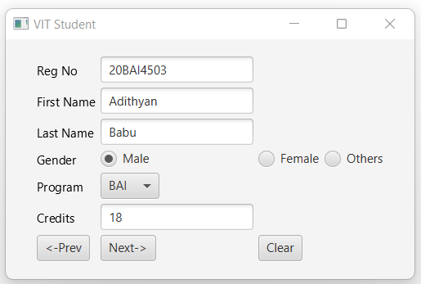

1. **Develop a JavaFX program to modify a student data. Include a textfield to read the RegNo of the student, display the details of that student obtained from the table in appropriate controls. The user should be allowed to modify only the NoOfCreditsEarned. Once new value is entered, provide a ‘Update Record’ button to update the record.**

**OUTPUT:**

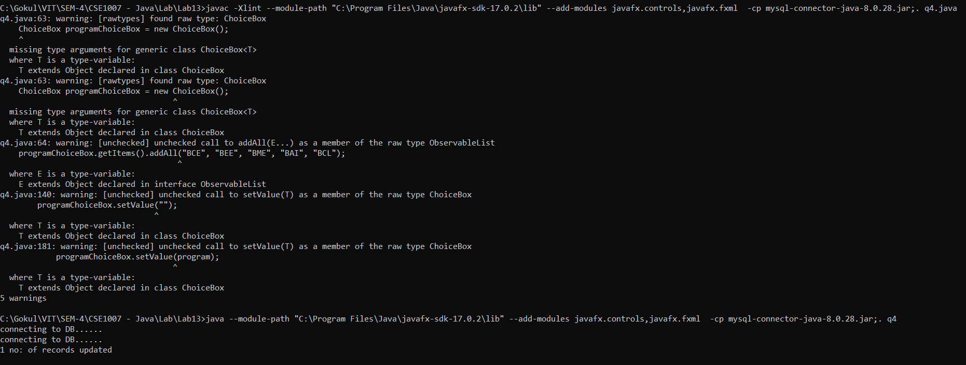

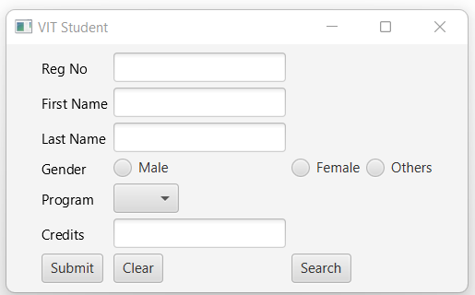

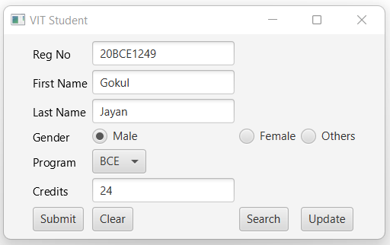

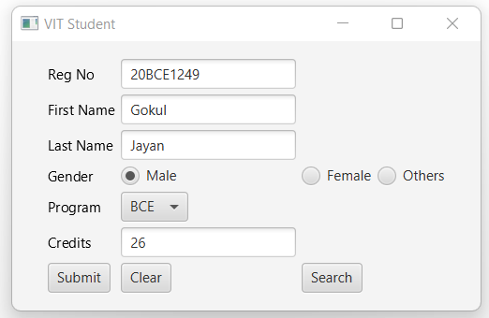

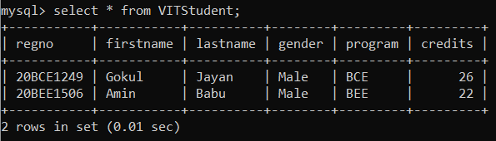

1. **Develop a JavaFX program to remove a student data. Include a textfield to read the RegNo of the student, display the details of that student obtained from the table in appropriate controls. Provide a ‘Delete Record’ button to remove the record.**

**OUTPUT:**

